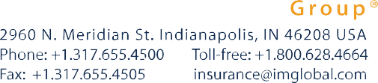

Date of Change Request:

To: Certificate Holder Services Premium Department
Email Address: epi@visitinsurance.com Fax: 703-991-9164

Insured Name:

Certificate Number:

Contact Phone Number: Email:
*We will use this information to contact you should there be a question about the information you are providing.

Dear International Medical Group:

Please update my payment information on file with the following:

Card Number: Expiration Date: _______________

Card Holders Name:

Signature:

Please note: All payments must be made and received in US Dollars. I hereby request and authorize International Medical Group, Inc. to charge my credit card. This authorization will remain in effect until revoked by me in writing and until International Medical Group Inc. actually received notice. Coverage purchased by credit card is subject to validation and acceptance by the Credit Card Company.

Other Comments:

